Section 1 (Computing the Inverse Transform Matrix):

1. The inverse of a translation undoes the original shift. A translation $(t_{x},t_{y})$ is inverted by a translation by $(-t_{x},{-t}_{y})$. Thus, the inverse translation matrix is: $\left[\begin{matrix}1 & 0 & {-t}_{x} \\ 0 & 1 & {-t}_{y} \\ 0 & 0 & 1\end{matrix}\right]$
2. The inverse of a rotation matrix corresponds to rotating by the opposite angle. Thus, the inverse of a rotation by $θ$ is a rotation by $-θ$. So, $R^{-1}=R^{T}$
3. The inverse of a reflection matrix is the reflection matrix itself because reflecting an object twice across the same line returns it to its original position.
4. Inverse of x-shear: $\left[\begin{matrix}1 & -k \\ 0 & 1\end{matrix}\right]$. Inverse of y-shear: $\left[\begin{matrix}1 & 0 \\ -k & 1\end{matrix}\right]$.

Section 2 (Implementing Image Transformations)

1. Scale:
   1. Function declaration: 

1. Reflect:
   1. Function declaration: 

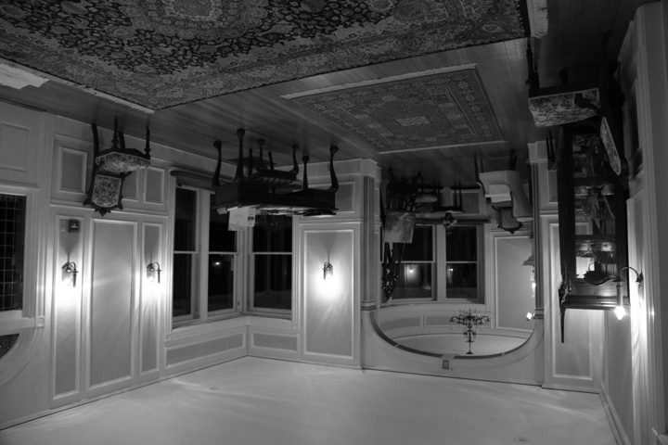

1. Rotate:
   1. Function declaration: 

1. Shear:
   1. Function declaration: 

1. Translate:
   1. Function declaration: 

1. Affine:
   1. Function declaration: 

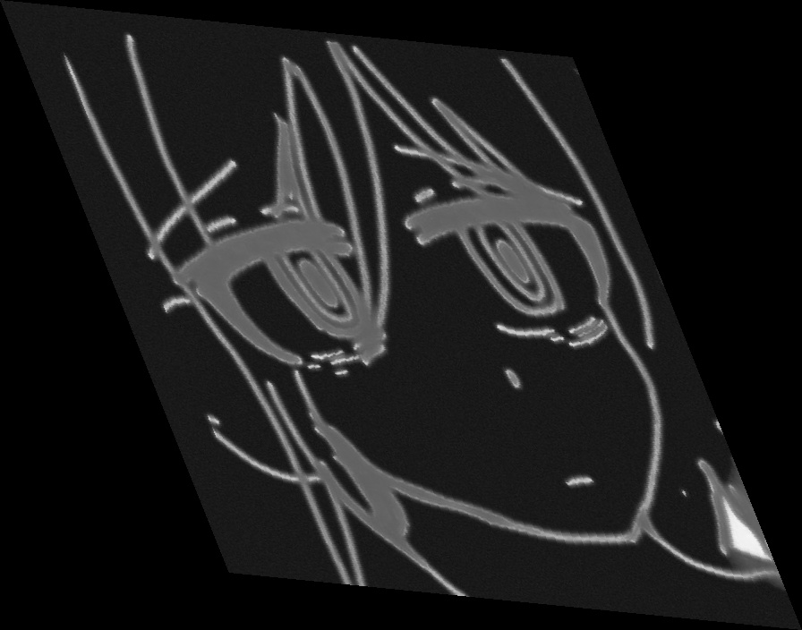

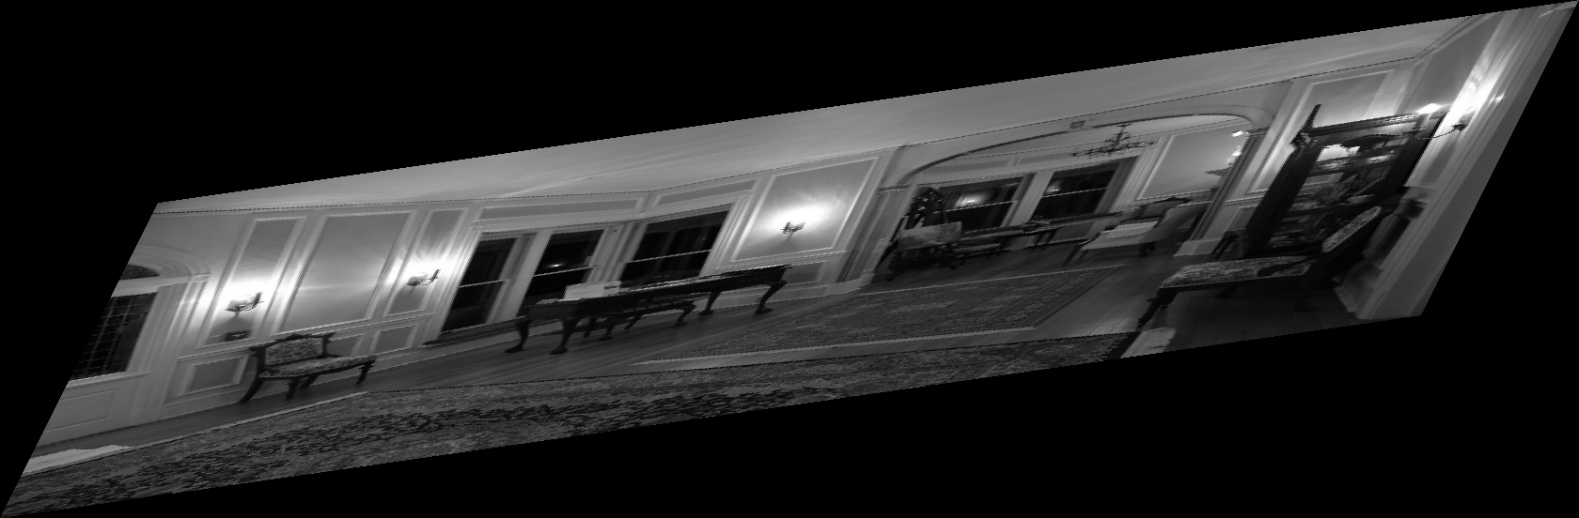

1. Homographies:
   1. Function declaration: 

